**Kalinga Institute of Industrial Technology**

**CN LAB-1**

NAME: Ankit Raj

ROLL NO: 1906534

**1. Swap two numbers using pointers**

**#include<stdio.h>**

**#include<stdlib.h>**

**int main()**

**{**

**int a_534,b_534;**

**scanf("%d%d",&a_534,&b_534);**

**printf("\nBefore swapping the values are ");**

**printf("%d %d\n",a_534,b_534);**

**int *p_534,*q_534;**

**p_534=&a_534;**

**q_534=&b_534;**

**int *temp;**

**temp=p_534;**

**p_534=q_534;**

**q_534=temp;**

**printf("\nAfter swapping the values are %d %d",*p_534,*q_534);**

**return 0;**

**}**

**OUTPUT:**

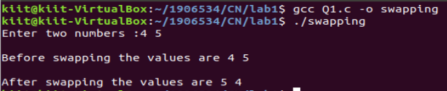

**2. Display student info using structure**

**#include<stdlib.h>**

**#include<stdio.h>**

**struct info**

**{**

**int roll_534;**

**char name_534[50];**

**float cgpa_534;**

**};**

**void display(struct info \**a_534*)**

**{**

**printf("roll no is %d\n name is %s\n cgpa is %f\n",*a_534*-**

**>roll_534,*a_534*->name_534,*a_534*->cgpa_534);**

**}**

**int main()**

**{**

**struct info *a_534=(struct info *)malloc(sizeof(struct info));**

**printf("\nEnter the details\t");**

**scanf("%d",&(a_534->roll_534));**

**scanf("%s",a_534->name_534);**

**scanf("%f",&(a_534->cgpa_534));**

**display(a_534);**

**return 0;**

**}**

**OUTPUT :**

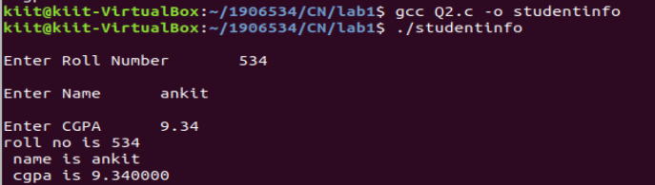

**3. Print the endianess of a number**

**#include<stdio.h>**

**#include<stdlib.h>void extract(int x_534)**

**{**

**int a_534,b_534,c_534,d_534;**

**a_534=x_534&0xff;**

**b_534=(x_534>>8)&0xff;**

**c_534=(x_534>>16)&0xff;**

**d_534=(x_534>>24)&0xff;**

**printf("%d %d %d %d",a_534,b_534,c_534,d_534);**

**}**

**int main()**

**{**

**int x_534;**

**scanf("%d",&x_534);**

**extract(x_534);**

**return 0;**

**}**

**OUTPUT :**

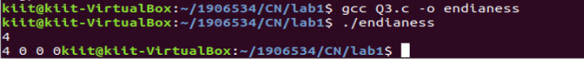

**4. Check whether your system is little endian or big endian**

**#include<stdio.h>**

**#include<stdlib.h>**

**void extract(int *x_534*)**

**{**

**int d_534;**

**if(d_534==*x_534*)**

**printf("\nBig endian\t");**

**else**

**printf("\nLittle endian\t");**

**}**

**int main()**

**{int x_534;**

**scanf("%d",&x_534);**

**extract(x_534);**

**return 0;**

**}**

**OUTPUT:**

